Rashid Lawal
[Company name] [Company address]
GLH proposal

Section 6 KPIs and User Acceptance Criteria
KPIs give GLH measurable targets to check whether the solution is actually working after it goes live. They are SMART Specific, Measurable, Achievable, Realistic and Timebound. User Acceptance Criteria (UAC) describe the specific things each type of user must be able to do for the solution to be signed off as fit for purpose.

Area | KPI / UAC | Target / Condition | How It Is Measured / Tested
Performance | Average page load time | Under 3 seconds | I will use google lighthouse audit on the main pages. All must scare above 80
Reliability | System uptime | 99.5% or more each month | I will use Uptimerobot which allows for GLH to check if the solution is up every minute. Monthly reports will be shared with GLH that tells them if any incident occurs
Customer Registration | UACC1: Customer registers and logs in | Done in under 3 minutes | The testers will register with valid data and then the conformation email arrives and one it works the account works
Customer Browse | UACC2: Catalogue filters work | Correct results, no page reload | The tester of the site will choose a random filter on the catalogue and also check for availability at the same time only matching in stock products should appear
Customer Checkout | Checkout success rate / UACC3 | 97% or above; checkout completes correctly | To measure the success rate I will divide the number of completed orders by the number of checkouts started in the database.
Customer Tracking | UACC4: Order status updates in real time | Visible within 10 seconds | The producers updates the order to Packed. The customer tracking page should show the new status within 10 seconds without needing a page refresh.
Customer Loyalty | Loyalty engagement / UACC5 | 40% or more of repeat customers redeem within 3 months; discount applied correctly | The rate is checked by querying the LoyaltyTransactions table. To test it, a tester earns points on a purchase, applies them at the next checkout, and checks that the correct £ discount comes off the total.
Customer Accessibility | UACC6: Mobile usability | All journeys work at 375px viewport | A tester completes the full journey browsing, checking out, and viewing their account on a 375px viewport. There should be no horizontal scrolling, all tap targets must be at least 44px, and the font size controls must work correctly.
Customer Satisfaction | Postorder satisfaction rating | Average 4.2 out of 5 or above | Inapp star rating shown 24 hours after delivery or collection is confirmed. Results stored in a Ratings table and shown to GHL

Section 8 Risks and Mitigation
Because GLH handles personal data, food products, and online payments, there are several laws and standards that the solution needs to comply with. I have listed each one below along with what it requires and how the solution addresses it.

Regulation / Standard | Priority level | How the Solution Addresses It
UK GDPR (2021) and Data Protection Act 2018 | High | Privacy policy on every page. Marketing optin is a separate checkbox (no pretick). Customers can download or delete their data. Retention periods set per data type.
Consumer Rights Act 2015 and Consumer Contracts Regulations 2013 | High | Cancellation rights shown at checkout and in accounts. Confirmation email includes 14day cancellation link. Producers own their descriptions; inaccurate listings can be flagged.
Food Information to Consumers (FIC) Regulation 2014 | High | Addproduct form has mandatory allergen checkboxes. Allergens, origin, net weight, and priceperunit shown on product page.
Payment Card Industry Data Security Standard (PCIDSS) | High | All payments handled by Stripe (PCIDSS Level 1 certified). Card details entered in Stripe iframe never touch GLH's server or database.
WCAG 2.1 Level AA | High | 4.5:1 contrast ratio throughout, alt text on all images, keyboard navigation, ARIA roles on dynamic content. axecore audit before launch.
Copyright, Designs and Patents Act 1988 | Medium | Assets log records source and licence for all thirdparty assets. Only CC0, CCBY, or opensource assets used. Producer images remain their property.
Privacy and Electronic Communications Regulations (PECR) 2003 | Medium | Cookie consent banner on first visit. Nonessential cookies only set after optin. Cookie policy lists all cookies by purpose and duration.

Looking ahead, GLH could extend traceability by adding QR codes to product labels that link directly to the product page. If the cooperative expands into home delivery, route optimisation software could reduce costs and environmental impact. AIdriven stock predictions might also help producers reduce food waste by forecasting demand

Section 11 Wider Issues

Privacy Beyond What the Law Requires
The GDPR sets the legal minimum but GLH has a responsibility to go further than that because it is a community cooperative. I am taking a privacyfirst approach, which means only collecting the data that is actually needed for each feature. I will not use things like preticked marketing boxes or hidden optouts that trick users into sharing more than they intended. Location data used to suggest a nearby collection point will not be stored past the current session. Any purchase history used for personalised recommendations will need a separate explicit optin, and customers can delete it at any time from their account settings.

User Support and Error Feedback
GLH's users include elderly customers who may not be confident with technology, and farmers who have never used a content management system before. The platform needs to give clear, helpful feedback when something goes wrong. All form validation errors will appear right next to the field that caused the problem, written in plain English rather than technical error codes. Every action that changes data placing an order, updating stock, changing account details will show a clear confirmation message so the user knows it worked. The checkout has a review page before final payment so customers can check everything before committing. The producer dashboard will have tooltip hints on each feature to explain what it does without needing a separate user manual.

Vulnerable Users
GLH tends to attract older customers who have long relationships with local farms. Older users may have reduced fine motor control, which is why all tap targets are at least 44px. They may also have lower contrast sensitivity, which is why a highcontrast mode is included. The checkout uses a progress bar and clear back navigation at every step so users can move through it at their own pace without feeling lost. Producers also need careful design consideration many are small farmers who do not use digital tools regularly. The producer dashboard is kept as simple as possible, with advanced features hidden behind a More options control so new users are not overwhelmed on their first login.

Environmental and Ethical Considerations
GLH's whole identity is built around environmental and ethical values local food, reduced food miles, sustainable farming, and supporting the local economy. The digital platform should not contradict those values. The hosting environment will be chosen with energy use in mind, prioritising cloud providers that run on renewable energy. Efficient database queries and WebP image compression reduce the energy used per page load. The realtime stock management feature also directly helps reduce food waste by keeping availability accurate. The platform's content will reflect the genuine diversity of GLH's producers and customers rather than using stereotyped rural imagery, and farming method descriptions will include conventional and transitional approaches alongside organic so no producer feels excluded.

Justification:

GLH Brief Requirement | How the Solution Meets It
Provide information about producers, their methods and the benefits of buying locally | The Why Buy Local content section (FR15) and individual producer profile pages give customers articles and farmlevel detail including farming method, certifications, and farm location. Each product detail page links directly to its producer profile so the traceability information is always one click away from the buying decision.
View products with transparent pricing and availability | The product catalogue (FR02) and product detail page (FR03) pull live prices and stock status from the database on every load. Producers keep this accurate through the dashboard (FR09). The FIC Regulation allergen display adds a further layer of transparency that supermarkets do not always provide at the point of sale.
Place orders for collection or delivery | The multistep checkout (FR05) supports both. Collection uses the timeslot calendar so GLH can manage how many orders it handles each day. Delivery uses a postcodebased shipping calculation. Both generate a full order record with a scheduled fulfilment date, which feeds into the order tracking timeline.
Manage accounts and view order history | The customer account dashboard covers order history (FR06), live order tracking (FR07), loyalty points balance (FR12), saved addresses, and accessibility preferences (FR14). Customers can manage everything about their GLH relationship without contacting staff.
Dashboard for producers to manage stock, product details and orders | The producer dashboard covers all three elements from the brief: stock management with RAG indicators (FR09), product detail editing with CRUD form and image upload (FR08), and an order queue with status controls (FR10).
Loyalty scheme with discounts and special offers | The loyalty engine (FR12) awards points when an order completes and lets customers redeem them as a £ discount at checkout. Special offers are set up by staff with start and end dates, so GLH can run seasonal promotions without any code changes.
Accessibility features for a wide range of users | FR14 delivers font size controls, highcontrast mode, full keyboard navigation, and ARIAcompliant markup. WCAG 2.1 AA compliance and the design decisions in Section 10 (wider issues) together make the platform genuinely usable rather than just technically passing an audit.

Why the Technology Choices Are Appropriate
I am using Python with Flask because it is the language I will use for Task 2, which means the design choices in this proposal will translate directly into the actual build. Flask is a lightweight framework it only includes what I actually need, which keeps the codebase simpler and reduces the attack surface. The sqlite3 library is built into Python so there are no extra dependencies to manage. SQLite is more than capable of handling the load for a single location cooperative. Bootstrap means I do not have to write a full responsive CSS system from scratch. Chart.js gives the producer dashboard a clean sales chart without adding a heavy dependency. Stripe handles payment security in a way I could not replicate myself, and using it removes the biggest compliance obligation PCIDSS card data handling from the application entirely.

Looking ahead, GLH could extend traceability by adding QR codes to product labels that link directly to the product page. If the cooperative expands into home delivery, route optimisation software could reduce costs and environmental impact. Ai driven stock predictions might also help producers reduce food waste by forecasting demand

Appendix
I looked at several existing websites and apps to see how they handle food retail, traceability, and user experience. Here's what I found.

I looked at Riverford's website because they're one of the best-known organic veg box schemes in the UK.

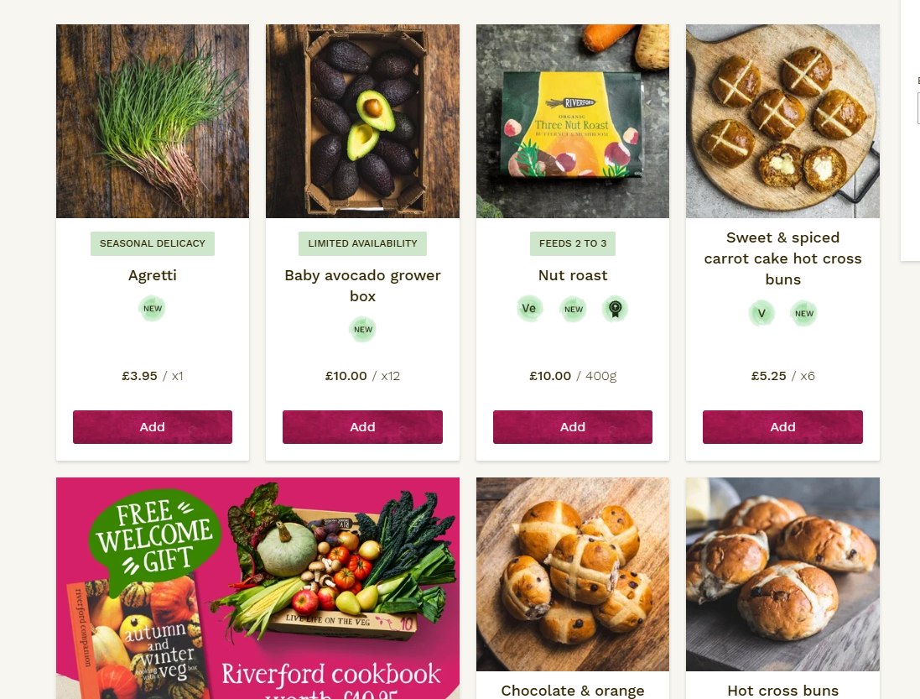
Riverford(2025)
Their product pages are really clear. Each one shows the price, weight, origin, farming method, organic certification, and allergen information all on one page. You don't have to click around to find where the food came from — it's right there. I really liked this and used it as a model for Product Detail and Traceability

I also looked at Amazon Fresh because they're a major player in online grocery.

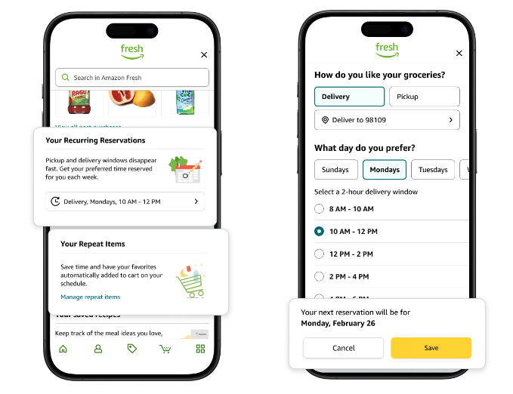
(Amazon Fresh)
Their checkout has a time-slot calendar where you pick a 1-2 hour delivery window. It shows which slots are still available, so you're not guessing. I used this idea for FR05 — GLH's checkout will have a similar calendar for collection slots.

They also have real-time order tracking. After you order, you can see exactly where it is — packed, dispatched, out for delivery. The status updates without refreshing the page. This gave me the idea for UAC-C4 (order status updates within 10 seconds).

Another thing I spotted: if an item is out of stock, you can't add it to your basket at all. The button is just disabled. That's exactly what I want for GLH — no overselling. Also, allergens are shown in bold on product pages, which is good for FIC compliance.

Emerging Technologies
I also looked into some emerging technologies that GLH might use in the future.
QR code traceability — The GS1 standard for QR codes on food packaging is being rolled out across supermarkets. Customers could scan a code on the product label and see exactly where it came from, who grew it, and when. This would extend GLH's traceability beyond the website into the physical product.
AI stock prediction — Waitrose and Tesco are already using machine learning to forecast demand. It helps them reduce food waste by ordering the right amount. GLH's producers could use something similar — the dashboard might one day show predicted demand for the next few weeks.
Route optimisation — If GLH ever expands to home delivery, route planning software (like Google's OR-Tools) could work out the most efficient order to deliver to multiple addresses. That would save fuel and cut costs.
Progressive Web Apps (PWAs) — Some sites now work offline using service workers. If GLH became a PWA, customers in rural areas with bad signal could still browse the catalogue. They could even add it to their phone home screen without going through an app store.

Regulations Research
I also read up on the regulations that apply to GLH.
GDPR — I learned that I can only collect data that's actually needed. Customers have to be told what I'm collecting and why. They also have the right to see their data, correct it, or ask for it to be deleted. Marketing emails need proper opt-in consent — no pre-ticked boxes.
Consumer Rights Act 2015 / Consumer Contracts Regulations 2013 — For online sales, customers have 14 days to cancel. The refund policy has to be shown before they pay. Order confirmations count as a contract, so they need to be clear.
Food Information to Consumers (FIC) Regulation 2014 — All 14 allergens have to be listed and highlighted (usually in bold). For fresh produce, origin has to be shown. Net weight and unit price also have to be visible.
PCI-DSS — If you handle card payments yourself, you have to comply with strict security rules. But if you use a certified provider like Stripe, they handle all of it. Stripe is PCI-DSS Level 1 certified, so that's what I'll use.
WCAG 2.1 AA — Websites have to be accessible. That means 4.5:1 contrast ratio, alt text on images, keyboard navigation, and ARIA roles for screen readers. I've built all of this into my design.
Copyright Act 1988 — Any images, fonts, or code I use have to be licensed properly. I'll keep an assets log to track where everything came from. Only CC0, CC-BY, or open-source assets will be used.
PECR 2003 — Cookie consent is required before setting non-essential cookies. I'll put a banner on first visit and only set analytics cookies after opt-in. A cookie policy will list everything by name and purpose.

Sources used

Source | What I Used It For
https://www.riverford.co.uk/ (accessed March 2025) | Product page design (FR03), allergen display, traceability features
amazon.co.uk/fresh (accessed March 2025) | Time-slot calendar (FR05), order tracking (UAC-C4), out-of-stock handling (UAC-P3)
oddbox.co.uk (accessed March 2025) | Stripe payment integration, subscription model research
localfood.org.uk (accessed March 2025) | Multi-producer dashboard design (UAC-P1), producer isolation
https://creativecommons.org/ | CC0 and CC-BY licence research for assets log
ico.org.uk/for-organisations/guide-to-pecr/ | PECR 2003 — cookie consent requirements
w3.org/WAI/standards-guidelines/wcag/ | WCAG 2.1 AA — contrast ratios, keyboard navigation, ARIA
pcisecuritystandards.org | PCI-DSS requirements — confirmed Stripe as Level 1 certified
food.gov.uk/allergen-labelling | FIC Regulation 2014 — 14 allergens, origin labelling
legislation.gov.uk/consumer-rights-act-2015 | Consumer Rights Act 2015 — cancellation rights
gov.uk/data-protection | GDPR and Data Protection Act 2018 requirements

